I.3.b. Use Statement

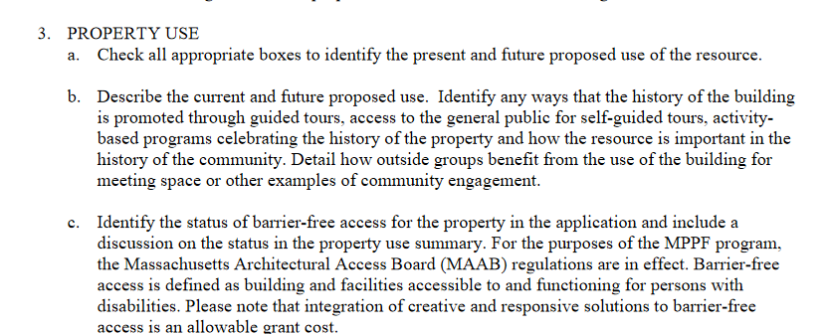

While Sunday service and Sunday school are the weekly highlight of First Congregational Church mission, we are active here every day with a variety of events that reach out into the community. We are part of the “free church” tradition and as such our members guide the community involvement, every member contributing from their own talents; as one member put it, “we stick our noses in everything”. After an 11-week hiatus in the spring at the onset of the COVID pandemic, First Congregational returned to in-person church services in May, with the addition of stringent COVID protocols and the addition of online streaming of services. This has proved popular with members old and new.

First Congregational often hosts events that are open to the public that focus on local and regional history; one example is a recent presentation by Leo Martin, author of *Pilgrim Pursuit of Happiness*, titled “How 51 Pilgrims Changed the World”. Free yoga classes on Tuesday and Thursday evenings at the church are open to the public; these resumed with COVID safety measures in place this past August. A Fall Book Study of C.S. Lewis’ *Mere Christianity* will take place on eight Thursdays beginning in October, with options for both Zoom and in-person attendance. An event that draws people from throughout the community, whether or not they have any affiliation with First Congregational, is the annual Blessing of the Animals in October, a family event with church service, a petting zoo and pony rides; the church works with Faxon Animal Rescue League of Greater Fall River to coordinate a pet food and supplies drive at this time. Guided tours of the church that explain its history and architecture are available by appointment only.

First Congregational supports several college-bound students with scholarships each year; recent recipients are majoring in music, education and nursing. The Mission Committee recently held a successful clothing drive for children in our community who were entering foster care. Once a month we run a soup kitchen.

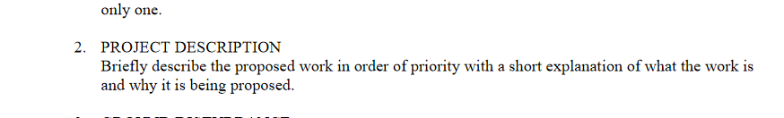

The stately Gothic Revival stone building features a four-story bell tower that houses a Revere Boston bell, over the narthex at the east side of the church. The condition of the tower, constructed of red brick masonry clad in Westerly granite, is deteriorating and needs restoration to ensure its safety and maintenance. All exterior mortar must be cut and re-pointed. Bulging buttresses must be dismantled and rebuilt, and buttress areas internally intact need to be anchored from the inside. Areas of cracked or drifted granite must be re-set with cross-ties. The cast stone belfry window must be replicated. The wood window frames and finials on the tower spires require restoration.

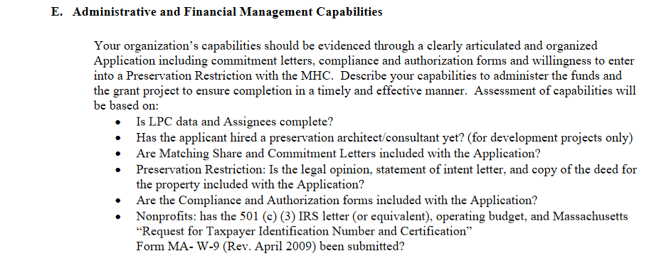

First Congregational has a long-established and successful tradition of stewardship and administrative capability. We employ an administrative professional 20 hours per week and a bookkeeper approximately 10 hours per week. Our books are reviewed annually by a CPA. Our Treasurer is a CPA and several other board members also have significant financial experience. We use bookkeeping software and are able and willing to set up an MPPF grant as a separate budget for ease of review.

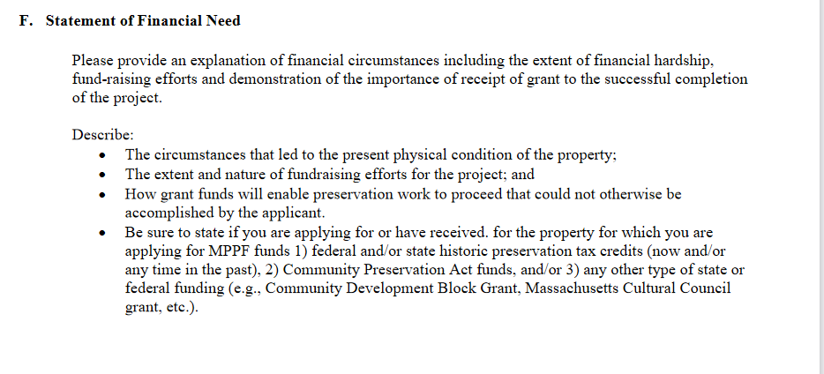

First Congregational is raising funds all the time for a variety of outreach and mission projects as well as for support for the operating budget of the church; it is an institution with many commitments to its community. We are fortunate to own the land and the building, donated by Sarah. S. Brayton in 1910; a trust was established then for the maintenance of the structure. Church members of the early part of the last century could hardly have foreseen the skyrocketing costs of restoration. A new estimate showed that the total costs for the tower restoration have risen by almost 20% just in the past 18 months since a previous estimate. The present condition of the tower was caused not by neglect but by time. With the grant funds to supplement the necessary restoration, we will be able to not only secure the safety and continued use of the tower, but to restore it to its former historically accurate appearance.